Types of Routes
# Source: AI Source: Provided by: [Data Path: Persons Table -> ID Column: 1, Name_En Column: Motasem Essam] -> From: [ChatGPT] on [1/16/2026]
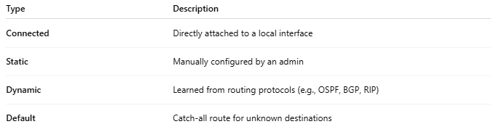
Type | Description
Connected | Directly attached to a local interface
Static | Manually configured by an admin
Dynamic | Learned from routing protocols (e.g., OSPF, BGP, RIP)
Default | Catch-all route for unknown destinations

